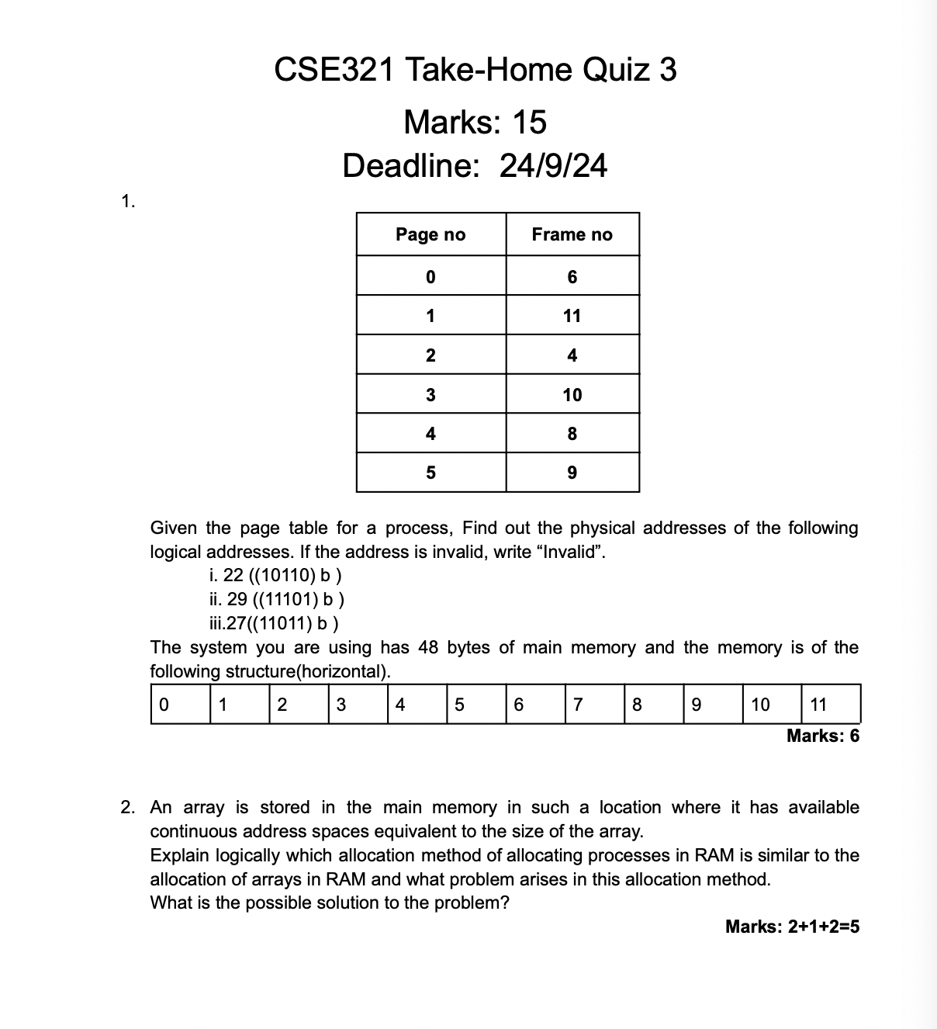

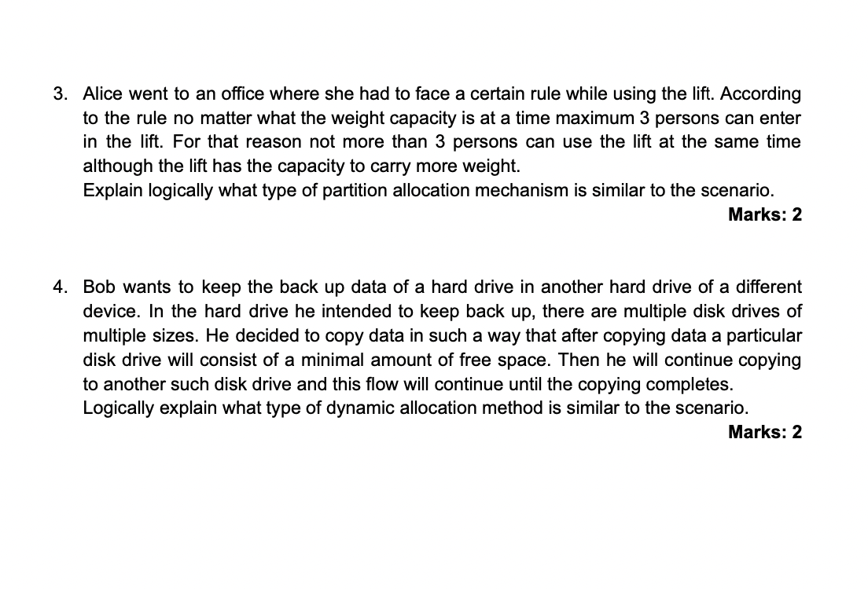

**Ans 1**

i) Physical Address for this is 38. Because the given page limits 0-5. Binary of 5 needs 3 bits. For 10110, Page no is 101 and offset is 10. As 101= 5 and frame for page 5 is 9 (given). Binary of 9= 1001 and after adding offset, it will be 100110. That means 38.

ii) Invalid. page no 7 doesn't exist in the given table.

iii) Invalid. page no 7 doesn't exist in the given table.

**Ans 2**

Allocation method similar to array storage in RAM is Contiguous memory allocation. Because it requires a single, continuous block of memory to store data elements sequentially.

Problem: Fragmentation. Because it occurs when free memory is split into non-contiguous blocks, preventing new processes from being allocated despite sufficient total memory and Contiguous memory allocation creates this issue.

Solution: Compaction in dynamic allocation, which rearranges memory to consolidate free space into larger contiguous blocks. Alternatively, paging can be used to allocate non-contiguous memory, effectively reducing fragmentation issues.

**Ans 3**

The scenario resembles fixed partition allocation in memory management, where memory is divided into fixed-size partitions. Just as the lift allows a maximum of three persons regardless of its weight capacity, fixed partition allocation limits the number of processes per partition, which can lead to inefficiencies. This setup ensures that no partition is overfilled, mirroring the lift's restriction.

**Ans 4**

It resembles the best-fit allocation used in memory management. As he aims to store data in the smallest available disk drive that can accommodate it, minimizing leftover free space. This approach efficiently utilizes disk space by ensuring that each drive is filled as much as possible before moving on to the next one, similar to how best-fit seeks to optimize memory usage by minimizing wasted space.